Accreditation Management System for the College of Computer Studies of De La Salle University-Manila – Instruction and Faculty

Rain Bautista1, Jansen Borja 2, Nikole Chan3, Kirsten Miranda4 and Geanne Franco5*

*1, 2, 3, 4 & 5 De La Salle University-Manila*

*\*Corresponding Author: geanne.franco@dlsu.edu.ph*

**Abstract:** As one of the top model universities in the Philippines, De La Salle University-Manila (DLSU-M) is accredited by the Philippine Accrediting Association of Schools, Colleges, and Universities (PAASCU) in multiple programs, indicating that the accredited programs meet certain standards set by the governing organisation and provide quality education to its enrolled students. PAASCU, being a member of international quality and education assurance committees and organisations, requires candidate and member institutions to implement their recommendations and provide evidences of the implementation.

With numerous faculty and several documents and files per faculty to manage, files and data often go undeclared. Currently, data is collected passively, where faculty submit only when asked to. Based on the data gathered from interviews conducted with the Quality Assurance Officer (QAO) of CCS, there have also been occurrences where faculty say that they have submitted, but the data or file cannot be found because they did not submit anything in the first place.

To solve the previously mentioned problems, an accreditation management system was developed with the Rapid Application Development (RAD) methodology; the system will act as a central repository for all of the documents and files to be uploaded as evidences, aid in task delegation and quality assurance, and unify the encoding of faculty data in order to address the problems encountered by the accreditation office of the College of Computer Studies (CCS) of DLSU-M. The system and its forms are based on the Faculty Information Forms (FIF) currently being used by the faculty of CCS, as well as the latest version of the Instruction and Faculty Evaluation forms of PAASCU.

**Key Words:** Accreditation Management; Central Repository; Plan, Do, Check, Act; Continuous Quality Improvement; Quality Management System

1. INTRODUCTION

Being one of the top model universities in the country does not come without being accredited, especially by one of the country’s most renowned accreditation service organizations known as the Philippine Accrediting Association of Schools, Colleges, and Universities (PAASCU), which is officially recognized and endorsed by the Department of Education (DepEd), a member of the International Network for Quality Assurance Agencies in Higher Education (INQAAHE), and has linkages with the Council for Higher Education Accreditation (CHEA), which is a national organization that coordinates accreditation activity with the National Committee on Foreign Medical Education and Accreditation (NCFMEA) (Conchada & Tiongco, 2015). The process of accreditation requires the submission of documents and certifications as well as the academic backgrounds and professional experiences of each faculty in the program or school to be accredited. With the great amount of files and documents to be received, keeping track of all the files, records, and tasks has proven to be difficult, especially with all the different certifications that a single faculty could receive in five years.

As a way to plan and manage the tasks and documents that will be collected and used as evidences, an accreditation management system for faculty and instruction-related documents will be proposed. This project will promote a more continuous quality improvement-oriented planning and management process.

2. METHODOLOGY

*2.1 Description*

The team has chosen rapid application development method or RAD for their system development. RAD allows projects to follow tight timescales with the use of prototyping and high-level development tools and techniques (Coleman & Verbruggen, 1998). The rationale for choosing this development is its flexibility to incorporate new suggestions and user inputs which is essential to satisfy user’s requirements. Users will be able to have a clear goal. As the process continues, the final product gradually evolves.

*2.2 Rationale*

Rapid Application Development, also known as RAD, attempts to divide the project into smaller phases as it aims to provide a system of high quality at a relatively fast pace of development. RAD was the chosen methodology as it exhibited most of the redeeming qualities of the other methodologies covered by the proponents, such as the Waterfall and Prototyping methods.

Because of flexibility and consistent demand for no room for errors, the Waterfall methodology was ruled out completely since it does not provide any room for adjustments and cannot switch from phase to phase. For the prototyping methodology, the proponents’ decided to forego from utilizing it since it is only a part of the bigger methodology with a greater scope, which is the RAD methodology.

*2.3 Phases*

*2.3.1 Requirements Planning*

In the requirements planning phase, the proponents formulated questions for scheduled interviews with Ms. Jenina Obieta, the Quality Assurance Officer of the CCS Accreditation Office. Information about DLSU’s PAASCU accreditation preparation processes and the process’ information bottlenecks were gathered during the interview, as well as the current organisational structure and system feature recommendations since the Quality Assurance Officer plays an important part throughout the entire accreditation process.

*2.3.2 User Design*

The user design phase involves the creation of the system design outline. System generated reports, the system process flow, and data relationships are defined. In this phase, Joint Application Development techniques were used to translate the needs of the users into models.

*2.3.3 Construction*

In the construction phase, the construction of the system itself begins. After construction of the system, test data will be generated and used to test the system’s capabilities and for error checking purposes. Additionally, system documentation will be produced to serve as a manual or guide in using the system.

*2.3.4 Implementation*

Data conversion, testing, and conversion to the new system will be done in the implementation phase. Data conversion is necessary so that the existing data will be able to be inputted into the new system. User training for the system will also be conducted to orient the system users on the system’s usage and features to so that it is used to the fullest extent.

3. RESULTS AND DISCUSSION

Because this study did not require the conduction of a survey or the use of formulas, screenshots of the system are provided instead.

The system aims to aid in maximising user productivity through the provided system tools and features. Tools such as visual representations of summarised data were designed in order to aid in the decision making of the Chair and the Quality Assurance Officer.

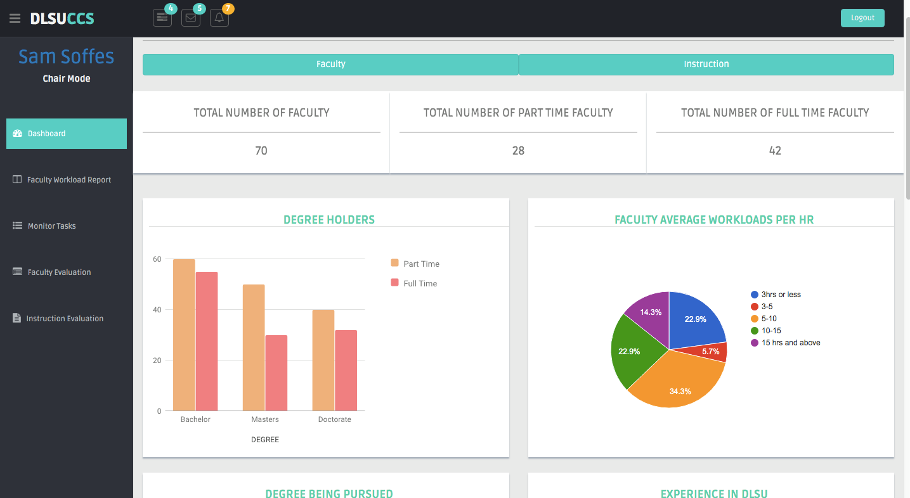

Fig. 1. Dashboard of the Chair, where data and statistics of all the faculty are summarised and represented visually.

The faculty will be able to receive notifications of tasks assigned to them. So that the faculty will not need to access the system to just receive notifications of tasks, the faculty will also receive notifications via e-mail once the task is created by the Committee Head.

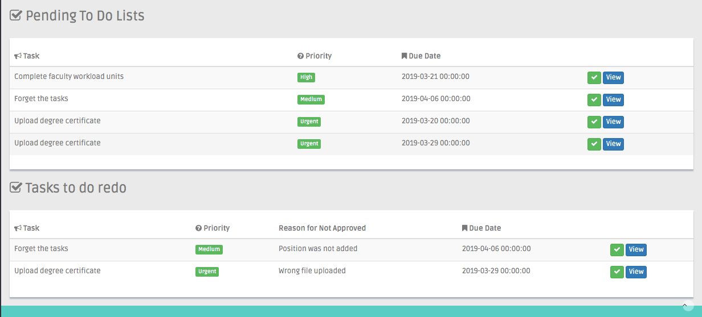

Fig. 2. Pending tasks seen by the faculty where the faculty can see all the tasks they have been assigned and tasked to redo based on the QAO’s comments.

4. CONCLUSIONS

The proposed system, if used properly, will be able to promote the continuous improvement of the planning and management of the PAASCU accreditation processes of De La Salle University-Manila. With the features and modules of the system, data and evidence collection, declaration, and management are simplified. Task delegation and monitoring will be almost effortless with the use of the system for the several contributors of the accreditation process will be equipped with an account to ensure the compliance of the process participants.

With the systems features, data uniformity and centralisation of files and information will be promoted; the need for repetitive tasks will also be lessened.

5. ACKNOWLEDGMENTS

We would like to acknowledge our parents who, despite the failures we have encountered, continued to support us. We would also like to acknowledge the professors we have had the opportunity to learn from throughout our stay in DLSU, we would not be where we are now without you.

6. REFERENCES

ASQ. (n.d.). *What is a Quality Management System (QMS)? – ISO 9001 & other Quality Management Systems.* Retrieved July 25, 2018, from http://asq.org/learn-about-quality/quality-management-system/

Bernik, M., Sondari, M. C., & Indika, D. R. (2017). Model of Quality Management System to Maintain Quality Consistency in Higher Education. Review of Integrative Business and Economics Research, 6(4), 235.

Coleman, G., & Verbruggen, R. (1998). *A quality software process for rapid application development*. Software Quality Journal, 7(2), 107-122.

Conchada, M.I.P. & M.M. Tiongco. (2015). *A review of the accreditation system for Philippine higher education institutions*. Retrieved July 25, 2018 from http://dirp3.pids.gov.ph/webportal/CDN/PUBLICATIONS/pidsdps1530.pdf.

Education Standard Authority. (n.d.). *Collect samples*. Retrieved July 25, 2018, from http://educationstandards.nsw.edu.au/wps/portal/nesa/teacher-accreditation/proficient-teacher/evidence/collect-samples

Gupta, A. (2000), “Quality management practices of ISO vs non‐ISO companies: a case of Indian industry”, Industrial Management & Data Systems, Vol. 100 No. 9, pp. 451‐5.

Faganel, A., & Dolinšek, S. (2012). Quality management systems in higher education. University of Primorska. Slovenia.

Johnson, C. N. (2002). The benefits of PDCA. Quality Progress, 35(5), 120.

J., M., S., C., & Amaral, A. (2012). Implementing Quality Management Systems in Higher Education Institutions. Quality Assurance And Management. doi:10.5772/33922

Noble, I. S. O. (2006). ISO 9000 quality systems handbook.

Ng, Kim-Soon. (2012). Quality Management System and Practices. 10.5772/36671.

Piskar, F., & Dolinsek, S. (2006). Implementation of the ISO 9001: from QMS to business model. Industrial Management & Data Systems, 106(9), 1333-1343.

Sampaio, P., Saraiva, P., & Guimarães Rodrigues, A. (2009). ISO 9001 certification research: questions, answers and approaches. International Journal of Quality & Reliability Management, 26(1), 38-58.

Sari, Y., Wibisono, E., Wahyudi, R. D., & Lio, Y. (2017, November). From ISO 9001: 2008 to ISO 9001: 2015:

Significant changes and their impacts to aspiring organizations. In IOP Conference Series: Materials Science and Engineering (Vol. 273, No. 1, p. 012021). IOP Publishing.

Sokovic, M., Pavletic, D., & Pipan, K. K. (2010). Quality improvement methodologies–PDCA cycle, RADAR matrix, DMAIC and DFSS. Journal of achievements in materials and manufacturing engineering, 43(1), 476-483.